Discrete Math

Rachel Hurner, Erin Marsyla
Highland Elementary in Crookston, MN
rachelhurner@isd593.org, erinmarslya@isd593.org
2nd and 3rd Grade
Math Class is 1.5 hours daily
Everyday Math Curriculum

Executive Summary

- Unit Voting (Majority and Plurality) {2nd, Unit 7} [3rd, Unit 1]
The voting unit that is below will take about 5 lessons. The students will be able to explore the method of Majority voting and Plurality voting. Students will create a scenario where students will choose which type of voting they will use to determine a winner fairly.

II. Unit Money (Combinations) {2nd, Unit 5} [3rd, Unit 3]
The money unit that is below will take about 3 lessons. The goal of the unit is to have them think about the different combinations of coins they can use for a given amount. This will also help them practice the coin names and values.

III. Unit Geometry (Venn Diagrams, Geoboards, Combinations) {2nd, Unit 7} [3rd, Unit 4]
The Geometry unit below will take about 9 lessons. The students goals are to: name and compare attributes they find, measure the perimeter of a given shape using inches and centimeters, given one length and the perimeter of a shape students should be able to find the lengths of the other sides.
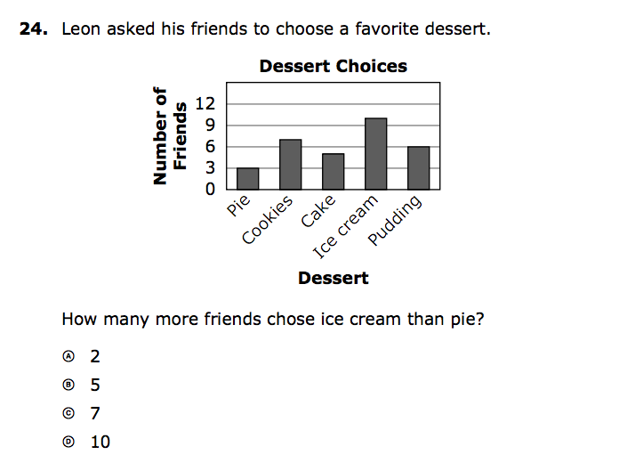

MCA Test questions
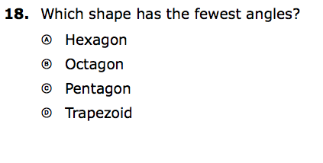

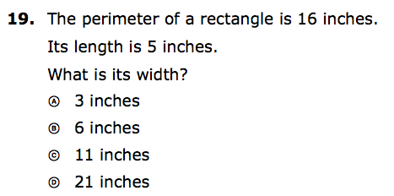

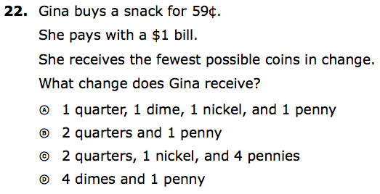

Table of Contents
Cover Page………………………..Page 1
Executive Summary……………..Page 2
Table of Contents………………...Page 4
Voting……………………………….Page 5
Money……………………………….Page 7
Geometry…………………………...Page 11

Citation: Pinterest.com for images

Voting
2nd Grade - 2.1.2.5 Solve real-world and mathematical addition and subtraction problems involving whole numbers with up to 2 digits.
2.1.2.6 Use addition and subtraction to create and obtain information from tables, bar graphs and tally charts.
(Unit 7)
3rd Grade- 3.4.1.1 Collect, display and interpret data using frequency tables, bar graphs, picture graphs and number line plots having a variety of scales. Use appropriate titles, labels and units.
(Unit 1)

Lesson 1:
Launch:
Who has ever voted on something? We use voting in the classroom, in the community, and in the government.

Pre-Assessment:
- 1 Who is the winner of this election? |  | 2. Which of these 3 candy are the winner?
Farmer Brown - 10 votes |  | Snickers - 8 | Which candy won?
Duck - 12 votes |  | Reeses - 10 | Is there a clear favorite of the candy?
Who won? |  | Skittles - 7

Launch:
One time that I really remember voting myself was which ride at DisneyWorld did we want to ride next. There were 6 people in our group.

Lesson 2 - majority voting
Discuss 50%
How to determine from our class what 50% looks like

Explore:
Options for exploring different situations for majority voting.

Two items and they need votes
Eating in the classroom or extra recess

3 items - extra recess, extra reading or extra homework
3 items - favorite time of the day: gym, lunch, recess

Lesson 3 - What do we need to do if the votes are the same
Let’s try some situations
Put students into groups and have them develop something to get votes for.
Visit other classes (one per group) to get votes.
After vote collection students create a frequency table (tally chart) showing their votes.

Lesson 4 - Share time
Share:
Groups share with the class their results from the previous days voting.
Have each student write down two interesting items they learned from the previous three day lessons.

Lesson 5 - Summarize what was learned with how to do voting and how to make it fair.

Post Assessment:
- 1 Who is the winner of this election? |  | 2. Which of these 3 candy are the winner?
Mickey Mouse- Votes 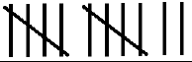 |  | Sour Patch Kids - | Which candy won?
Donald Duck - votes |  | Kit Kat - | Is there a clear favorite of the candy?
Who won? |  | Starburst - | Is there a candy that the students would not choose?

Money
2nd Grade Standards
2.3.3.2 Identify pennies, nickels, dimes and quarters. Find the value of a group of coins and determine combinations of coins that equal a given amount. (Unit 5)
3rd Grade Standards
3.3.3.3 Make change up to one dollar in several different ways, including with as few coins as possible. (Unit 3)

Pre-Assessment
Directions: Show the money amount with the least amount of coins.

1. $0.45 2. $0.35

3. $0.96 4. $0.24

Show two different coin combinations to come up with the same amount

5. $0.52 6. $0.49

7. $0.33 8. $0.74

Lesson 1:
Launch:
Yesterday I was Walmart and was checking out after getting my groceries. I got the amount that I owed for my bill but did not have the correct coins in my pocket to pay the cashier. I needed to give them 25 cents but I did not have any quarters in my pocket.

Explore:
With the coins at your desk, come up with at least two different ways that I could give the cashier 25 cents.

3rd Grade/Extension - I would change my launch slightly.
Launch:
Yesterday I was Walmart and was checking out after getting my groceries. I got the amount that I owed for my bill but did not have the correct change in my pocket to pay the cashier. I only had paper money with me. My bill was $13.45. I gave them $15.

Explore:
Go back to your desk and figure out one possible combination of change I could get from the cashier.

Lesson 2:
In Everyday math, we have a Name Collection Boxes. I would start off the lesson with the student write on the board the different combinations of coins that would equal the same amount of money.

Share:
How were you able to come up with different combinations to make the same amount of money. What is one way that you can check your amounts? (Counting money back with naming and using coin values)

Lesson 3: Venn Diagram Extension on money
Launch:
You have become a Money Maker and are heading to the mint to make your own coins! What are you going to make? Before you get to excited, please observe what your limits are for your new coin.

Copper Coins Silver Coins
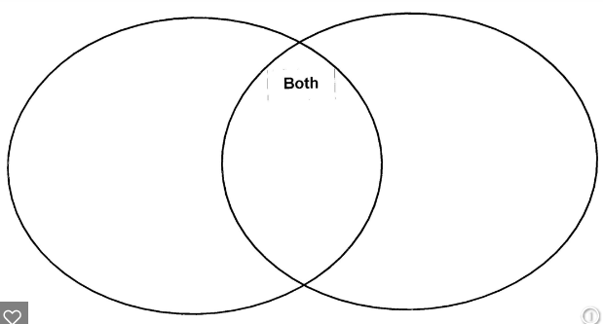

Edge with Ridges Smooth Edge

Post Assessment
Directions: Show the money amount with the least amount of coins.
1. $0.43 2. $0.53

3. $0.69 4. $0.42

Show two different coin combinations to come up with the same amount
5. $0.56 6. $0.48

7. $0.31 8. $0.77

Geometry
2nd Grade Standards
2.3.1.1 Describe, compare, and classify two- and three-dimensional figures according to number and shape of faces, and the number of sides, edges and vertices (corners).
2.3.1.2 Identify and name basic two- and three-dimensional shapes, such as squares, circles, triangles, rectangles, trapezoids, hexagons, cubes, rectangular prisms, cones, cylinders and spheres.
2.3.2.2 Demonstrate an understanding of the relationship between length and the numbers on a ruler by using a ruler to measure lengths to the nearest centimeter or inch.
(Unit 7)
3rd Grade Standards
3.3.1.1 Identify parallel and perpendicular lines in various contexts, and use them to describe and create geometric shapes, such asright triangles, rectangles, parallelograms and trapezoids.
3.3.1.2 Sketch polygons with a given number of sides or vertice (corners), such as pentagons, hexagons and octagons.
3.3.2.1Use half units when measuring distances.
3.3.2.2 Find the perimeter of a polygon by adding the lengths of the sides. Measure distances around objects.
(Unit 4)

Lesson 1: Attribute blocks and venn diagrams. Classify the different two-dimensional shapes.

Launch:
Here are a bunch of shapes. Who can tell me what they already know about these shapes. Shapes have many attributes about them. Take 3 minutes to write down three or more pieces of information on your whiteboard. WIll have the students then share what they are thinking to start. I would make a list of these things on poster paper for us to visit during the next couple days of lessons.

Pre-assessment would then be given. See the next page.

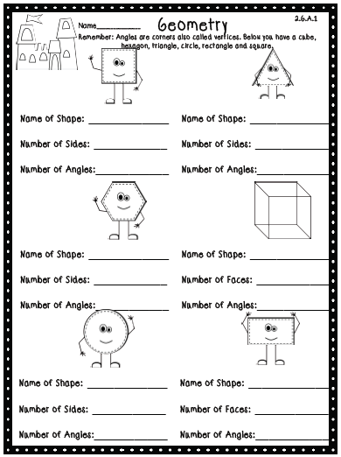

Once the pre-assessment is given. I would have the students then get their own set of attribute blocks at their desks. I would have a handout two pieces of string for them to make a venn diagram. We would then start discussing what different types of attributes we could sort the shapes by. As a class we would do an example of what a completed venn diagram will look like once a sort is done.

Lesson 2
Explore:
Cutting out the sorting shapes from the back of the math journals. Then the students would be given some exploration time, with a partner, to see what different labels they could find for the venn diagrams. They would be given the directions that they and their partner will have to explain one of the venn diagram sorting attributes that they used.

Lesson 3
Share:
Students would come back to the whole group. Students would share the completed venn diagrams they have found. During this time, the attributes that the shapes have would be compiled onto a sheet so that every student would end up with the same information to have for future lessons.

Lesson 4:
Explore:
With the same attributes from lesson 2 students will begin to explore the different types of line segments and angles that connect the shapes. In pairs they will once again complete a practice sheet where they describe one of their circles.

Share: With the class students will share their discoveries.

Lesson 5:
Summarize:
Discuss the different types of shapes identifying real-world examples of two-dimensional shapes.

Post Assessment:
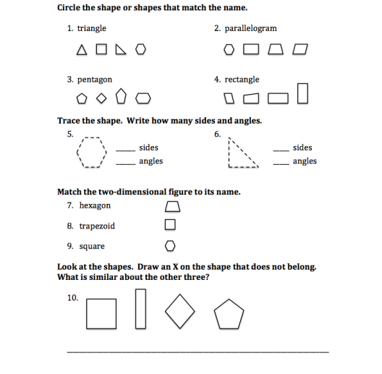

Lesson 6/7:
Pre-Assessment:
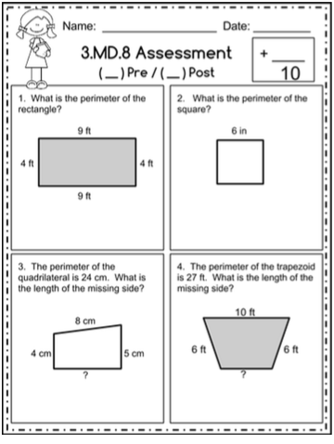
Use a centimeter/inch ruler to measure the truck shown below. Record the measure to the nearest centimeter and the nearest inch.
1. The length of the truck is _______ centimeters.
2. The length of the truck is ______ inches.
3. The truck is ____ inches tall. 4. The truck is ____ centimeters tall.

Explore/Share:
Use the geoboards to create the geometric shapes we have discussed in previous lessons and then use rulers to measure the perimeter of the shapes on the geoboards. Start thinking about what the inside might mean.

Once students have had time to explore on the geoboards, we would come together and share what we have found out so far.

Share:
What observations were found when you were measuring the shapes on your geoboard. Is there a difference if you use inches or centimeters?

Explore:
Send them back to their desks with the shapes that were cut out in a previous lesson and have the students find the perimeter of those shapes.

Share:
Now that we have talked about the shapes and perimeters once and you have explored them in two different mediums, what new information are you able to share with the class?

Lesson 8: 3rd Grade/Extension for 2nd Grade:
Explore:
Using the geoboards again have groups of students create shapes from a given perimeter.

Share:
Have the students share their shapes with the class and discuss the differences in the shapes that were created.

Explore:
Given the perimeter of a shape and the length of one side groups will create the polygon. What type of observations and conclusions can be drawn from this exercise would be shared.

Lesson 9:
Launch:
Give students another manipulative (popsicle sticks, toothpicks…) and have them continue to create shapes with a given perimeter. They will be given enough manipulatives to create many different shapes. Start to explore what the inside of the shapes would represent and how we might find that with the manipulatives we have. Discuss the fact that shapes with the same perimeter will not have the same area.

Lesson 10:
Create a class venn diagram on the different types of measurement (inches, feet, yard), (centimeters, meters). When doing this, we would make sure to preface to the students that we want them to have the most accurate measuring tool. For example, a pencil would not be measured by a yard.

Post Assessment:
Use a centimeter/inch ruler to measure the truck shown below. Record the measure to the nearest centimeter and the nearest inch.

1. The length of the truck is _______ centimeters.

2. The length of the truck is ______ inches.

3. The truck is ____ inches tall.

4. The truck is ____ centimeters tall.

Draw a line for each length given using a centimeter/inch ruler. In each pair, circle the measurement that represents the greater length.

5. a. 4 inches

b. 11 centimeters

6. a. 6 inches

b. 20 centimeters

7. a. 8 inches

b. 8 centimeters

Post Test continues on the next page
